SYM**✓**

**The Image-Based Self Diagnosis Web Application**

**User Manual**

**Contents**

**1. Getting Started...................................................................3**

1.2 Navigating to the application........................................3

1.3 Beginning a diagnosis....................................................5

**2. Uploading an Image............................................................8**

2.2 Navigating back to Welcome page..............................11

2.3 Finding the Nearest Emergency Room........................12

**3. Results………......................................................................15**

3.2 Navigating back to Welcome page..............................20

3.3 Finding the Nearest Emergency Room….....................21

**4. Starting a New Diagnosis...................................................23**

**5. FAQ Page………………………………………………………………………..25**

**6. Using the SymCheck Interactive Chatbot…………………………26**

**7. Submitting Feedback.........................................................28**

**Getting Started**

Welcome to the official user guide for SymCheck, an image-based self-diagnosis web application!

Before we begin, please ensure that you have the correct environment set up on your machine for running the SymCheck application via localhost, or have navigated to our cloud-hosted instance at: [insert cloud-hosted application URL here], instructions for both of which can be found in the *SymCheck Installation Manual*.

After setting up the proper environment on your machine, follow this guide to receive your own automatically generated diagnosis information.

***Please note that all images shown in this manual are for sample purposes ONLY. What you see on your own machine may look slightly different.

**Navigating to the Application**

SymCheck works on various browsers hosted on your local computer, including Google Chrome, Mozilla Firefox, Internet Explorer, and Microsoft Edge. (Some bugs have been found in the use of Safari, thus our team would recommend using an alternate browser until this issue can be resolved.)

Start by running your Python virtual environment as set up via the *SymCheck Installation Manual* on your computer. Then navigate to the folder containing all the files for the SymCheck application, and run the Django server via the manage.py file as demonstrated in the installation manual and below:

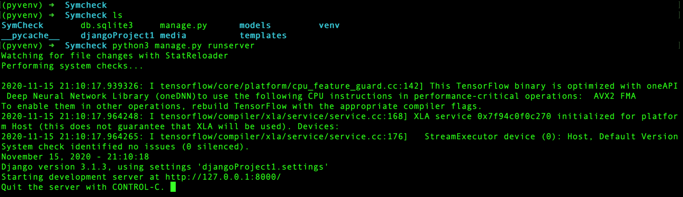

With the server running successfully, open your browser of choice and go to the localhost site outlined in your command line, i.e. <http://127.0.0.1:8000/> above, or simply <http://localhost:8000>.

Alternatively, you can simply navigate to: [insert cloud-hosted application URL here].

In either case, you should then see the following welcome page of the SymCheck application:

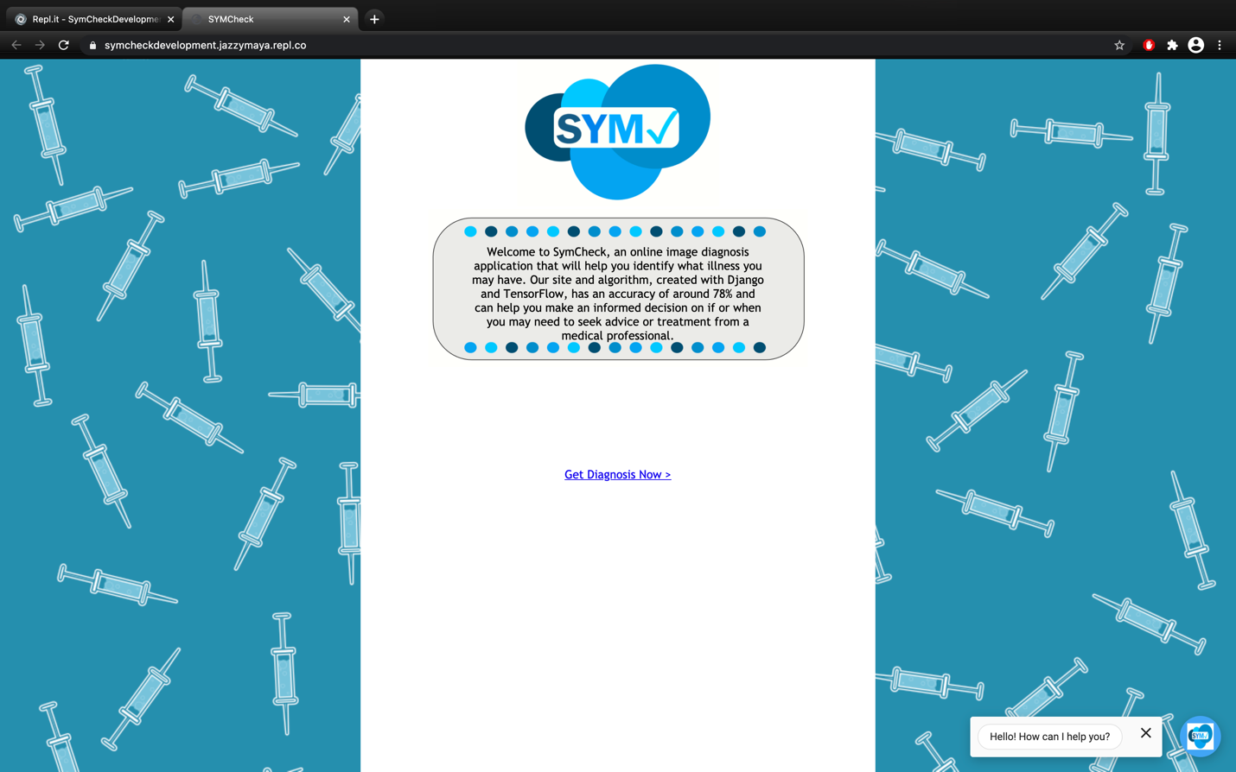

**Beginning a Diagnosis**

To begin a diagnosis, simply click on the “Get Diagnosis Now” link, to navigate to the application’s main image upload page as shown below:

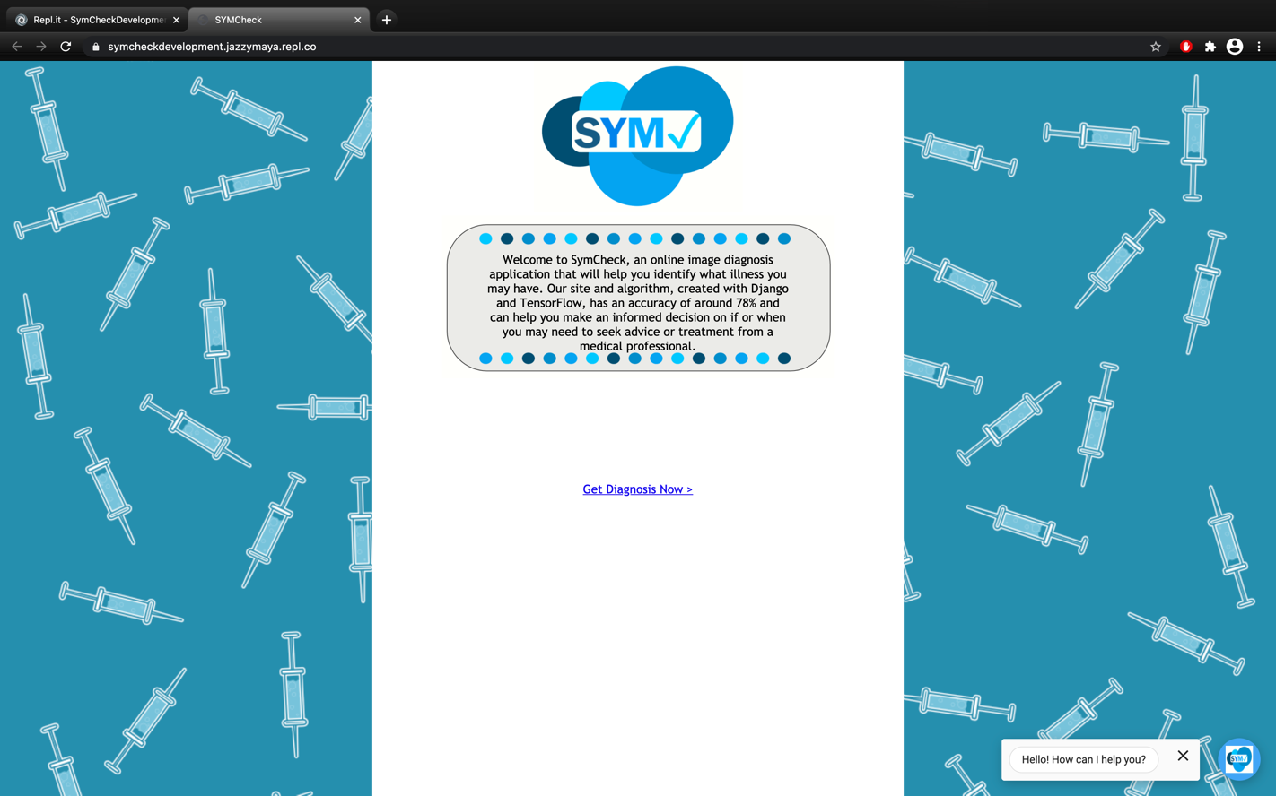

Clicking the link shown on the previous page should take you to the image upload page shown below:

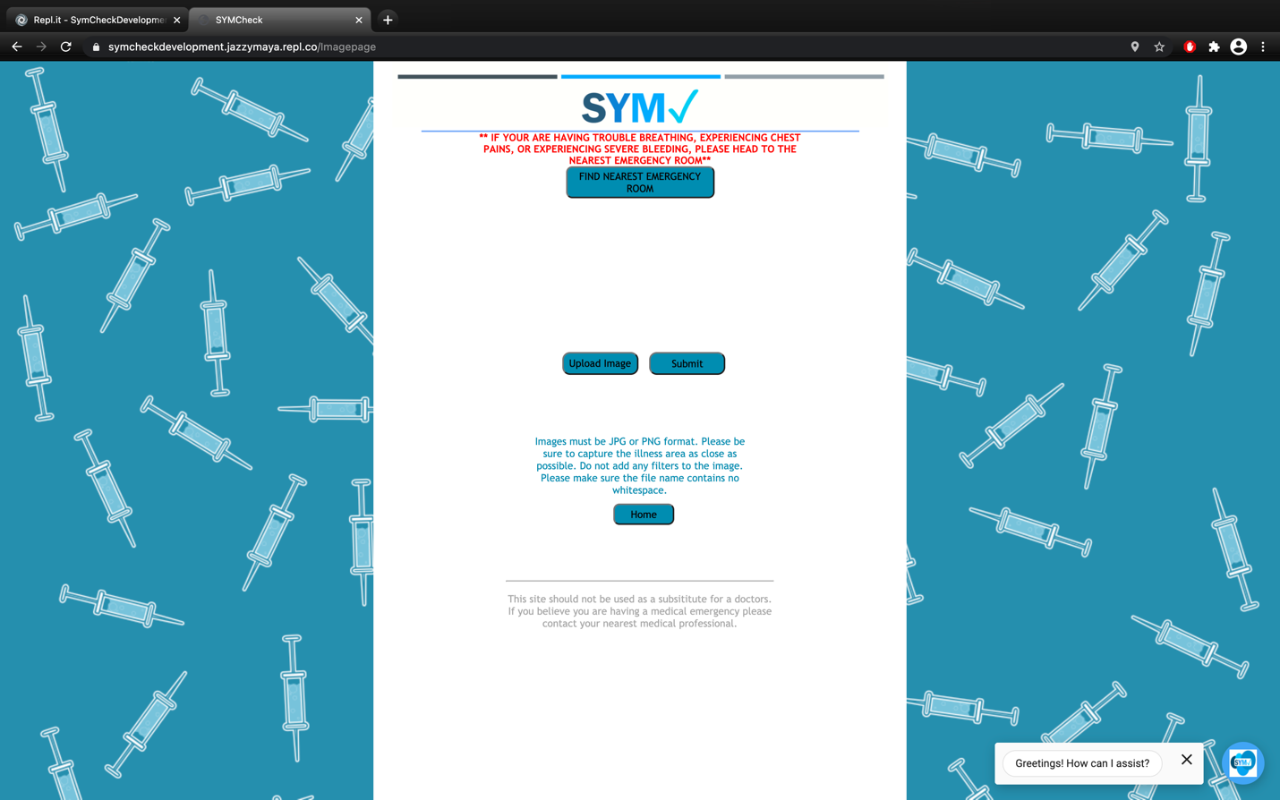

Great! Now we’re ready to upload an image of our illness!

**Uploading an Image**

We are now at the main image upload page of the SymCheck application. In order to upload an image of an illness, simply click on the “Upload Image” button shown below:



This will open your computer’s file browser from which you will be able to choose your desired image file. **Acceptable formats include .png and .jpg/.jpeg.**

Once you have chosen an acceptable image, a preview of your image should be displayed above the “Upload Image” and “Submit” buttons, indicating that your image has been uploaded successfully. Now click “Submit” to send your image to our backend machine-learning-based algorithm for classification while you navigate to the next page to see your Results!

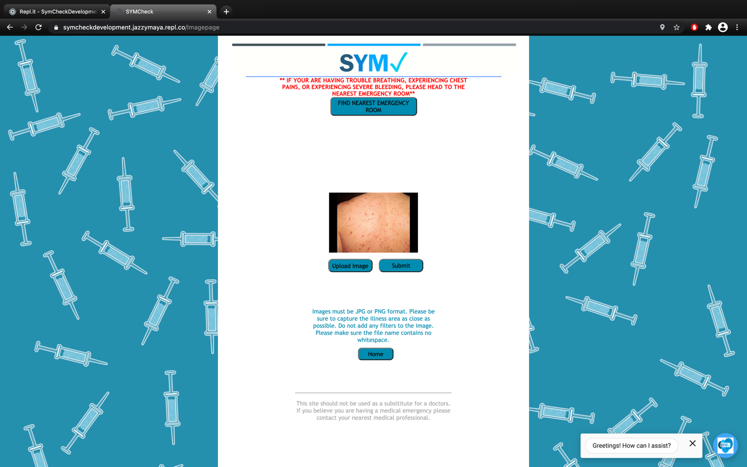

Clicking the “Submit” button should take you to the Results page shown below:

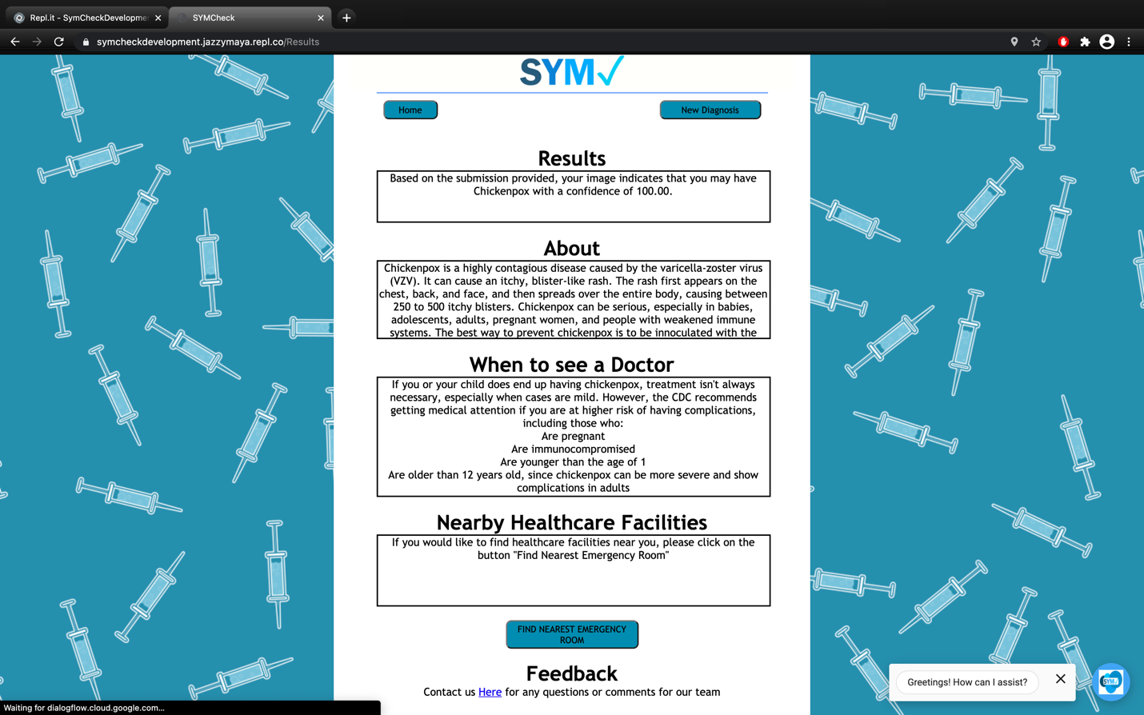

Please skip to **page 12** of the manual for an explanation of the Results page.

**Navigating back to the Welcome Page**

In the event that you find yourself on the Image Upload Page of our application but want to navigate back to the Welcome Page, simply click on the “Home” button, *or* click on the Back button of your browser:



**Finding the Nearest Emergency Room**

In the event that while you are using are application, your condition worsens to a worrisome level, or you simply decide you would rather seek help at a medical facility, simply click the “FIND THE NEAREST EMERGENCY ROOM” button shown below:



This will prompt the application to automatically open a map, pinpointing the locations of medical facilities nearest as shown on the next page:

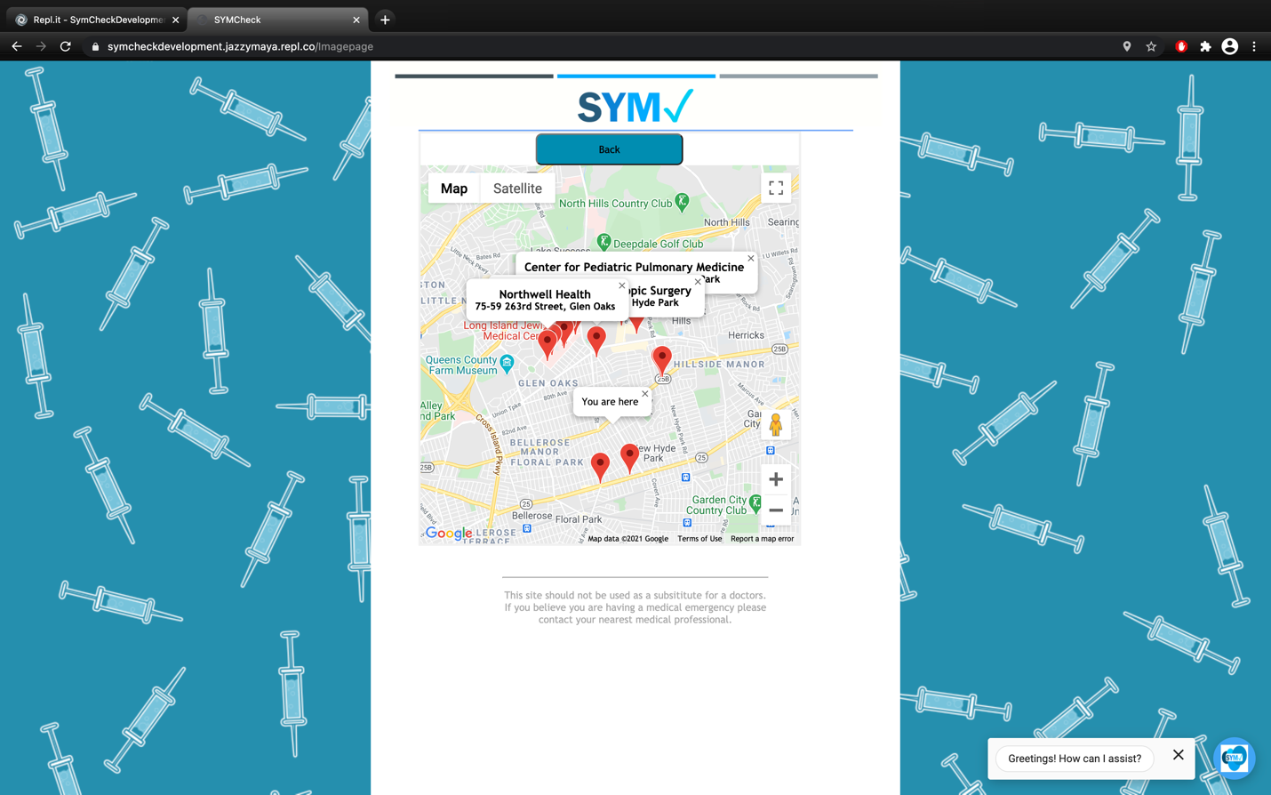

**\*\*\*Please note that using this function requires you to have Location Services enabled on your browser.** Be sure to click “Allow” when prompted to share your location as shown below:

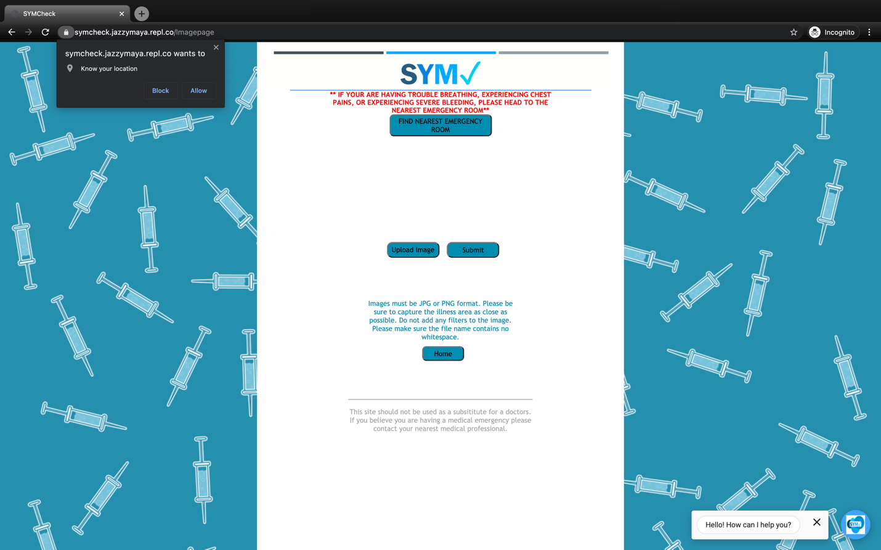

***This can also be done by navigating to your browser “Settings”.

**Results**

We are now on the Results page of the SymCheck application, a page with data generated uniquely for you based on the image you uploaded in the previous section of this manual:



***Please note that all text shown in the fields in the image above are for SAMPLE PURPOSES ONLY. What you see within each field will differ based on the classification of your illness.

On this page, you will see four different fields of information as shown above. In detail, they are:

The **Results** field which provides a metric of accuracy for the classification of your disease. In other word, this field provides information on the likelihood of your having a certain ailment, based on the image you submitted being run through our machine-learning algorithm.



The **About** field, which provides information regarding your specific ailment to further your understanding of the symptoms, risks, etc. This information is generally provided from acclaimed, official sources such as the CDC’s websites, with links provided:



The **When to see a Doctor** field, which outlines *specific* conditions under which you should definitely see a healthcare provider, regardless of a potential lack of severity of an illness. (These are generally cases where the user may be a young child/infant, pregnant, elderly, etc.):



And the **Nearby Healthcare Facilities** field which essentially prompts you to click the “FIND THE NEAREST EMERGENCY ROOM” button should you feel that you wish to seek professional care based on the information provided on this page:



**Navigating back to the Welcome Page**

In the event that you find yourself on the Results page of our application and want to navigate back to the Welcome Page, simply click on the “Home” button in the top left corner as shown below:



**Finding the Nearest Emergency Room**

In the event that given the information provided on the Results page, you wish to seek help or a professional diagnosis at a medical facility, simply click the “FIND THE NEAREST EMERGENCY ROOM” under the “Nearby Healthcare Facilities” field as shown below:



This will prompt the application to automatically open a map, pinpointing the locations of medical facilities nearest you:

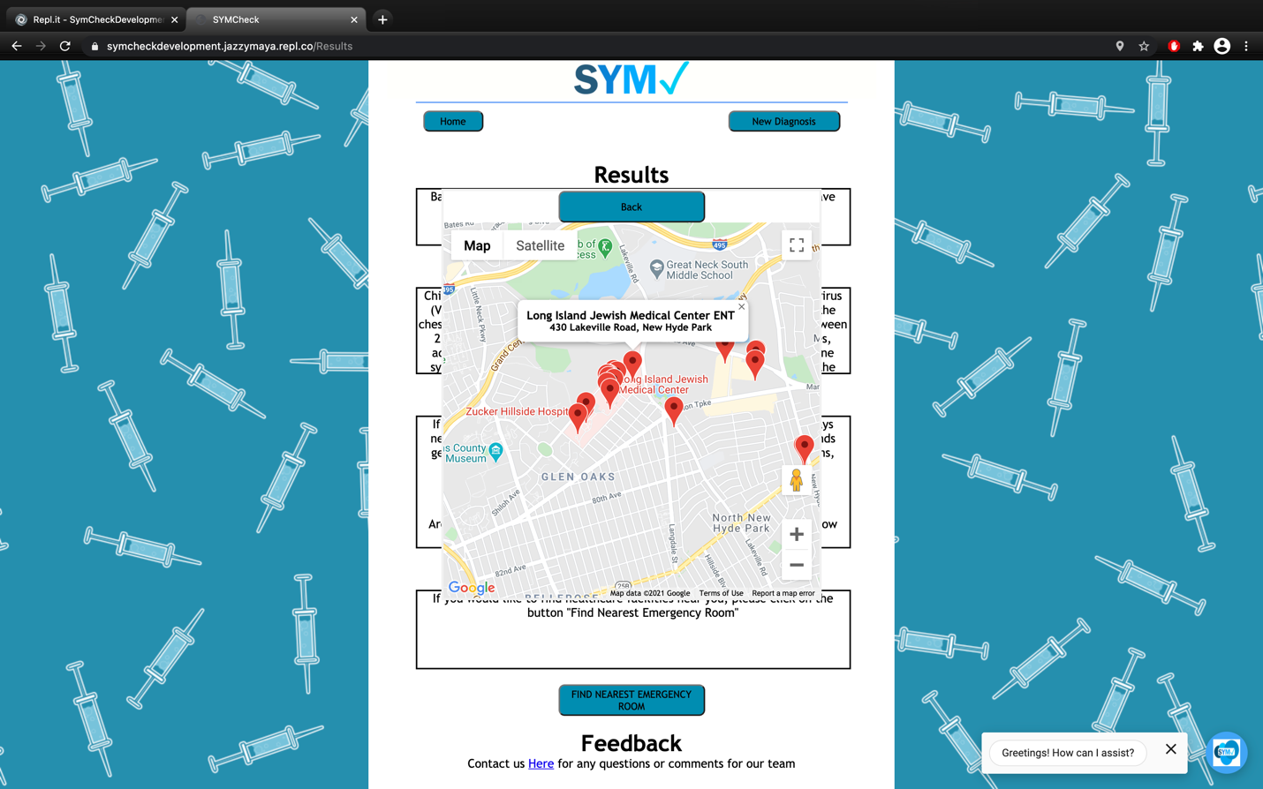

**\*\*\*Please note that using this function requires you to have Location Services enabled on your browser.** Be sure to click “Allow” when prompted to share your location, or navigate to the “Settings” in your browser to give SymCheck access to your location.

**Starting a New Diagnosis**

Once you have received an estimated diagnosis based on your image submission, you may want to start a new diagnosis for another image. To do this, simply navigate to the top right of the Results page to the “New Diagnosis” button:



Clicking this button will take you back to the Image Upload page, where you can upload another image, submit it, and then receive another diagnosis in the same way **(see page 7).**

Conversely, if you wish to start at the very beginning, you may also choose to start a new diagnosis by navigating back to the Welcome page by clicking the “Home” button on the top left corner of the Results page as shown below:



You can now get a new diagnosis by following through all the steps starting from **page 3** of this manual.

**FAQ Page**

SymCheck also allows you to navigate to a page containing the most “Frequently Asked Questions” related to SymCheck. This page can be accessed from any page of SymCheck, and allows users/patients to sift through a list of questions most often asked whilst using the application or navigating the website, as an alternative to posing questions to SymCheck’s interactive chatbot (see next page for details on chatbot):

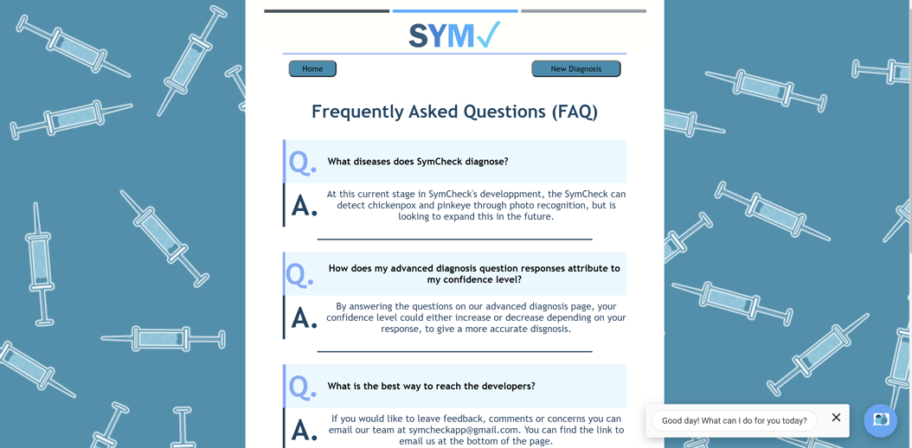

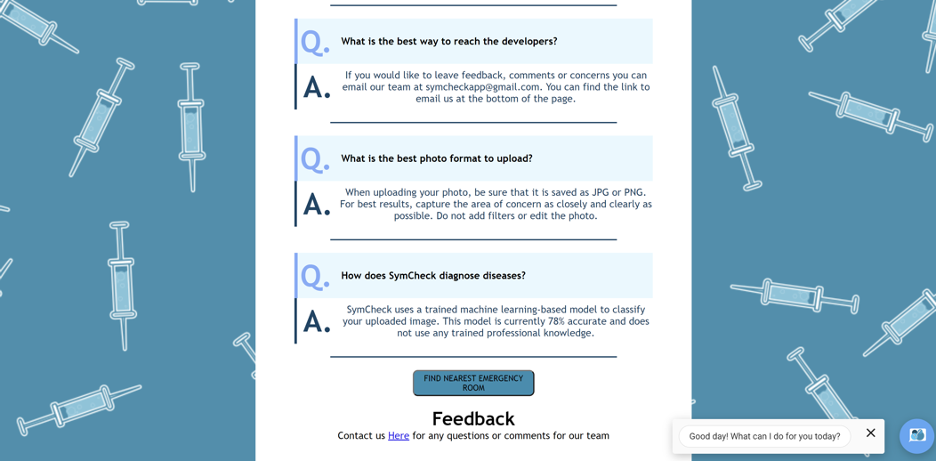

***The above images show the actual, current FAQ page of the SymCheck application

**Using the SymCheck Interactive Chatbot**

SymCheck hosts an interactive chat window on each and every page of the application as an alternative to navigating to the FAQ page, to which you can pose simple questions related to chickenpox or pinkeye, as well as on the general use of the application. The chatbot can be opened by simply clicking on the chat window to expand as shown in the image on the left below. And then you can ask a question in order to prompt the chatbot to respond with a pre-set response based on what question(s) has been asked:

|  |  |
| --- | --- |
|  |  |
|  |  |

The chatbot can then be closed by clicking on the “X” below the chat window to the right, as shown in the image on the left, and can even be hidden and unhidden altogether by simply clicking on the small SymCheck logo on the bottom right, as shown in the image on the right.

|  |  |
| --- | --- |
|  |  |

***Please note that while only the Homepage is shown in the images above, SymCheck’s interactive chatbot is available on every page of the application with all these functions.

**Submitting Feedback**

Once you have received your diagnosis/diagnoses, if you wish to provide any feedback on the SymCheck application, or contact the team for any form of support, simply click the link under the “Feedback” field on the very bottom of the Results page. This will prompt your browser to open an email window where you can then input any questions/comments/concerns to send to our team. 

Thanks so much, and we look forward to hearing from you!